- Pre-Requisites
  - Access to DocuSign (via IT Central)
  - Access to Adobe Acrobat Pro (via Emily Theriault)
  - Pre-Signed DxA Agreement: Labcorp - 2024 Electronic Form Diagnostic Assistant License Combined Finalv2 (MWF Edits).pdf
- Prior to Creation of DocuSign
  - When information is received from customer/rep confirm all fields have been submitted. This information is submitted via Microsoft Forms and sent to the approvals queue in Teams via a Power Automate workflow.
  - Items to Double Check Prior to Creating DocuSign:
    - Organization Full Legal Name
      - Go to (State) Secretary of State Business Entity database and look up the name provided. Confirm the name provided matches the name registered with the state.
        - If it does, proceed with generating agreement.
        - If it does not, send name found to rep/client and have them confirm.
      - If legal name provided is not found, could be a DBA name and need to confirm that with the rep as well.
    - Authorized Signer
      - If a larger group or multiple practices, make sure that the authorized signer provided does in fact have the correct authority to sign off on the agreement.
    - EHR:
      - If on NextGen, confirm they are on NextGen enterprise and NOT NextGen Office. If they are on version 6.2021.x, it is safe to assume they are on NextGen enterprise and can proceed.
      - If on Epic, confirm if it is OCHIN or standard. If standard, confirm they have their own tablespace or if they share a tablespace with a larger organization. If shared with a larger organization, cannot proceed as that organization needs to sign off on Diagnostic Assistant.
- Creating DocuSign
  - If all has been confirmed as correct from the previous step, proceed with generating the DocuSign.
  - Open the Pre-Signed DxA Agreement in Adobe Acrobat Pro
  - Select Edit PDF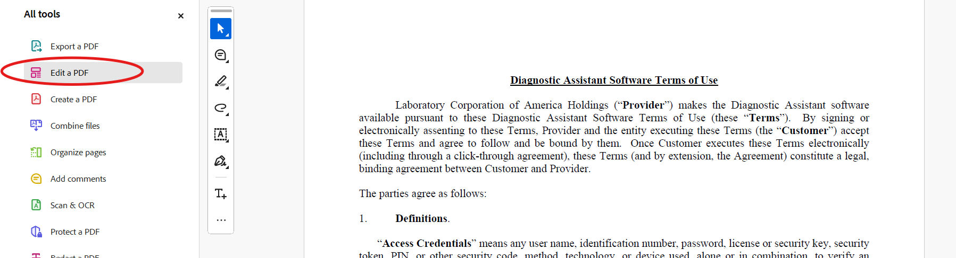
  - Under Add Content, Select Text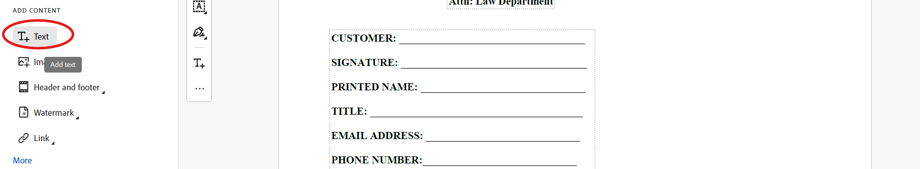
  - Add Text to each required field
    - Customer, Printed Name, Title, Email Address, Phone Number, Customer Address
    - Note: for Customer if the legal name provided has a DBA, please include the legal name as well as assumed name (e.g. Med Health Center, Inc. dba Med Health)
  - Add Text to optional fields
    - If on Athena, leave Practice Name and Athena Practice ID blank, for eClinicalWorks URL put N/A
    - If on eCW, leave eClinicalWorks URL blank, for Practice Name and Athena Practice ID put N/A
    - All other EHRs, put N/A for Practice Name, Athena Practice ID, and eClinicalWorks URL
  - Saving the file (IMPORTANT)
    - The name of the file impacts all automation workflows.
    - If a standard business name, save file name as Business Name Labcorp Diagnostic Assistant Software Terms of Use
    - If a DBA, only include the assumed name after the DBA, save as Assumed Name Labcorp Diagnostic Assistant Software Terms of Use
    - After saving, go to menu and select Protect using Password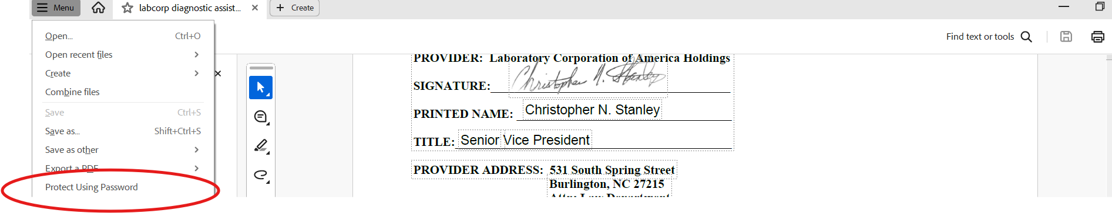
    - Select ‘Require a Password for Editing’ and input the following password
      - Dx@T34m! 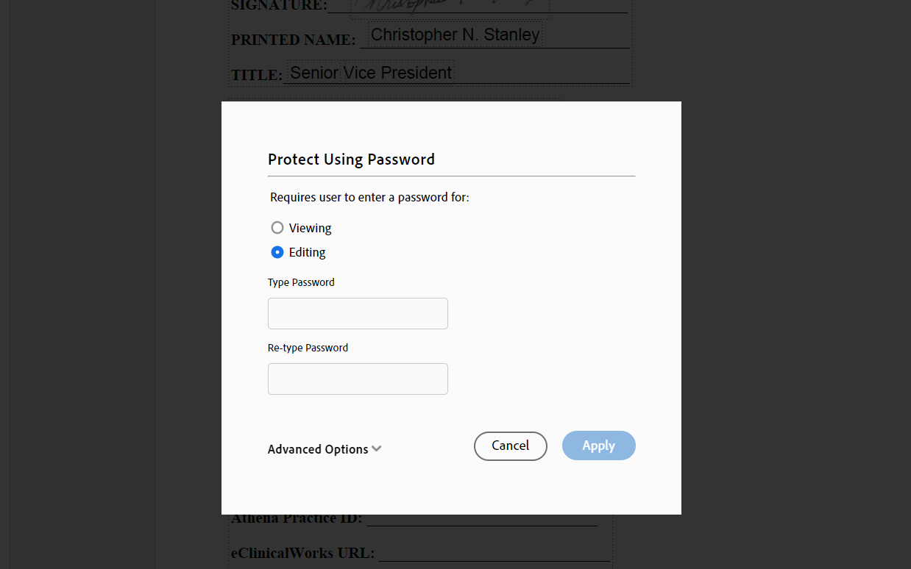
    - Once you select Apply, document is automatically saved and you can close out of the PDF.
- eCW and NextGen Automation
  - Prior to sending the DocuSign, eCW and NextGen customers have to be entered into their automation queue prior to sending. This automation queue is hosted in a shared excel file in the Diagnostic Assistant implementations Team channel.
  - In the Diagnostic Assistant Implementation Teams Channel, select DxA Contracts
    - For respective clients, open either eCW Automation.xlsx or NextGen Automation.xlsx
    - Input the information provided in the respective columns:
      - Client Name (Needs an exact match with the name the PDF was saved as)
      - Client Status – Manually set to In Contract
      - On Minimum Version – Manually enter yes
      - CKD Pilot (eCW only) – Manually enter No
      - Client Contact Name
      - Client Contact Email – if multiple, separate with ;
      - Sales Rep Email – if multiple, separate with ;
- Sending DocuSign
  - Select Start -> Envelopes -> Send an Envelope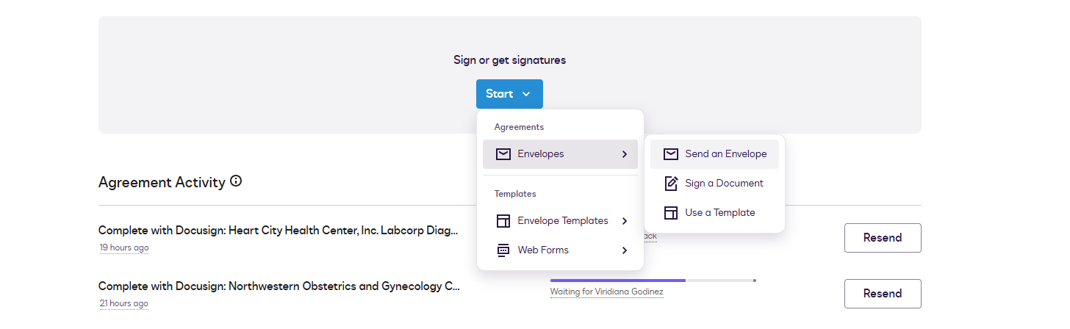
  - Upload PDF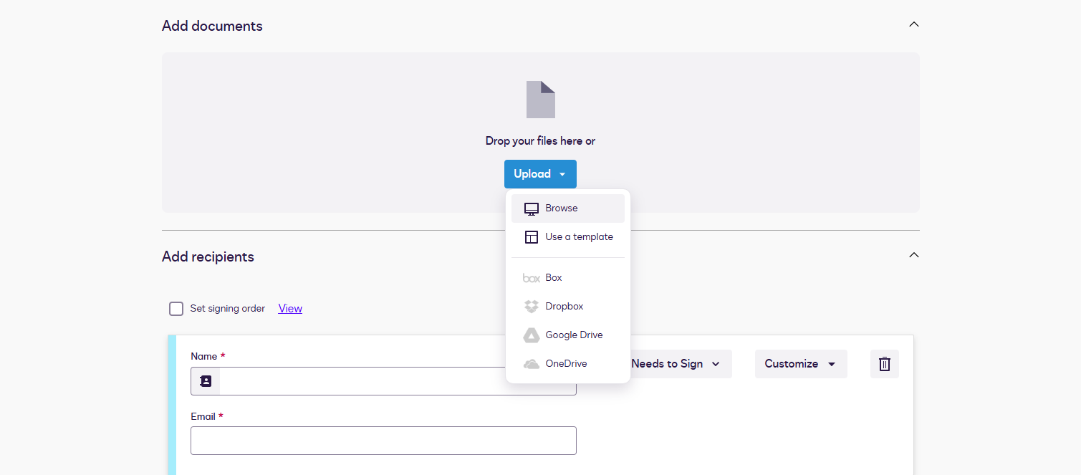
  - Select Advanced Options 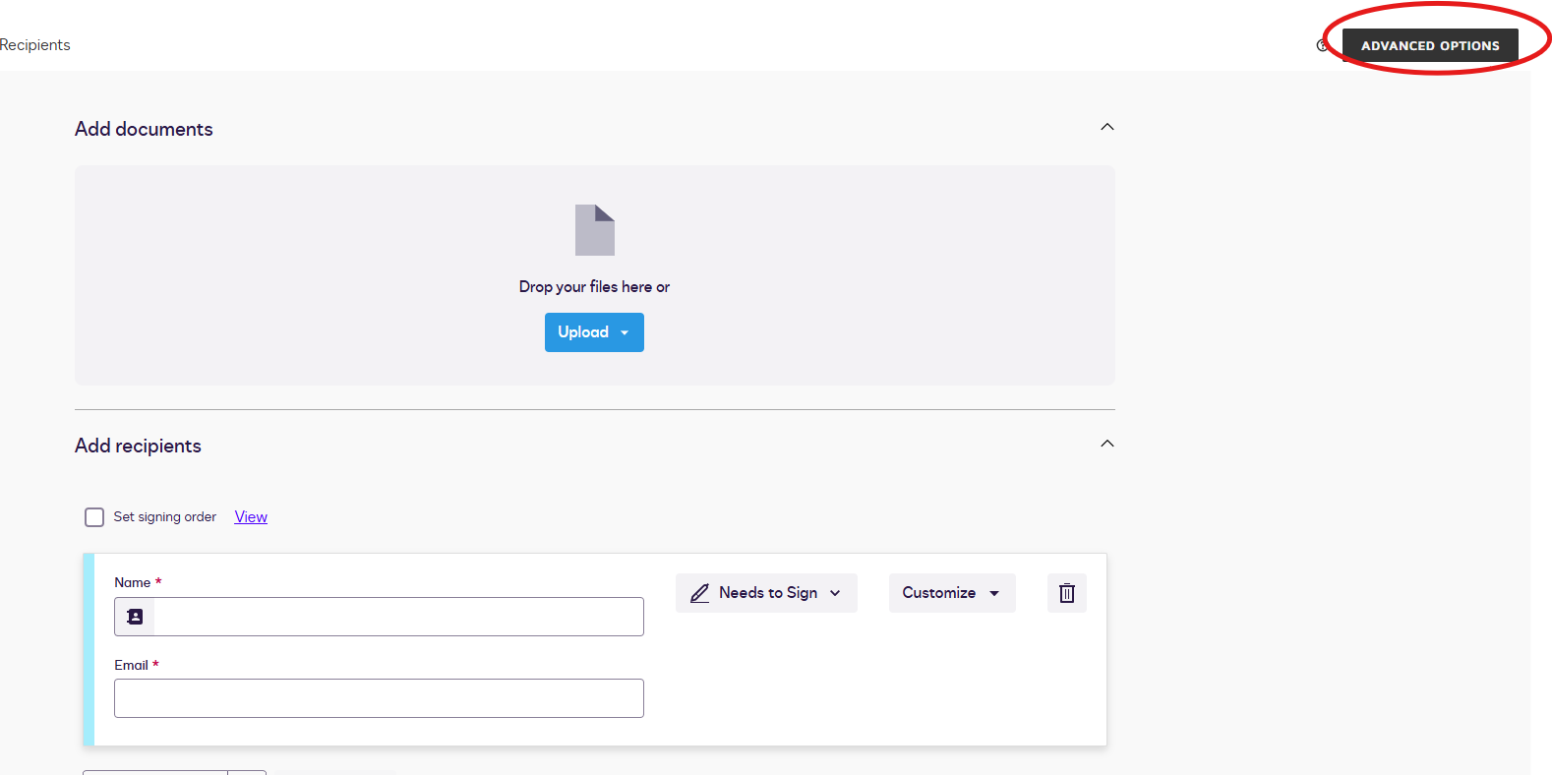
  - Uncheck ‘Recipients can change signing responsibility or assign a delegate’
  - Turn on Auto Reminders
    - Days before first reminder – 7 days
    - Repeat reminder – 7 days
  - Expiration
    - Days until envelope expires – 120 days (default)
    - Send alert – 7 days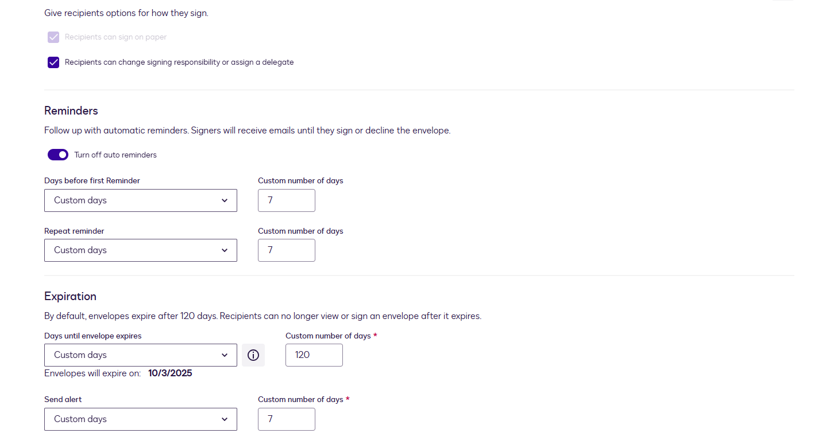
    - Once done, make sure to save
  - Add recipients
    - Set signing order by selecting the checkbox, order is as follows:
    - Set DxA team as first recipients, be sure to select “receives a Copy” in dropdown menu beside name and email
    - Set Sales Reps as second recipients, be sure to select “receives a Copy” in dropdown menu beside name and email
    - Set signer as last recipient, be sure to select “needs to sign” in dropdown menu beside name and email 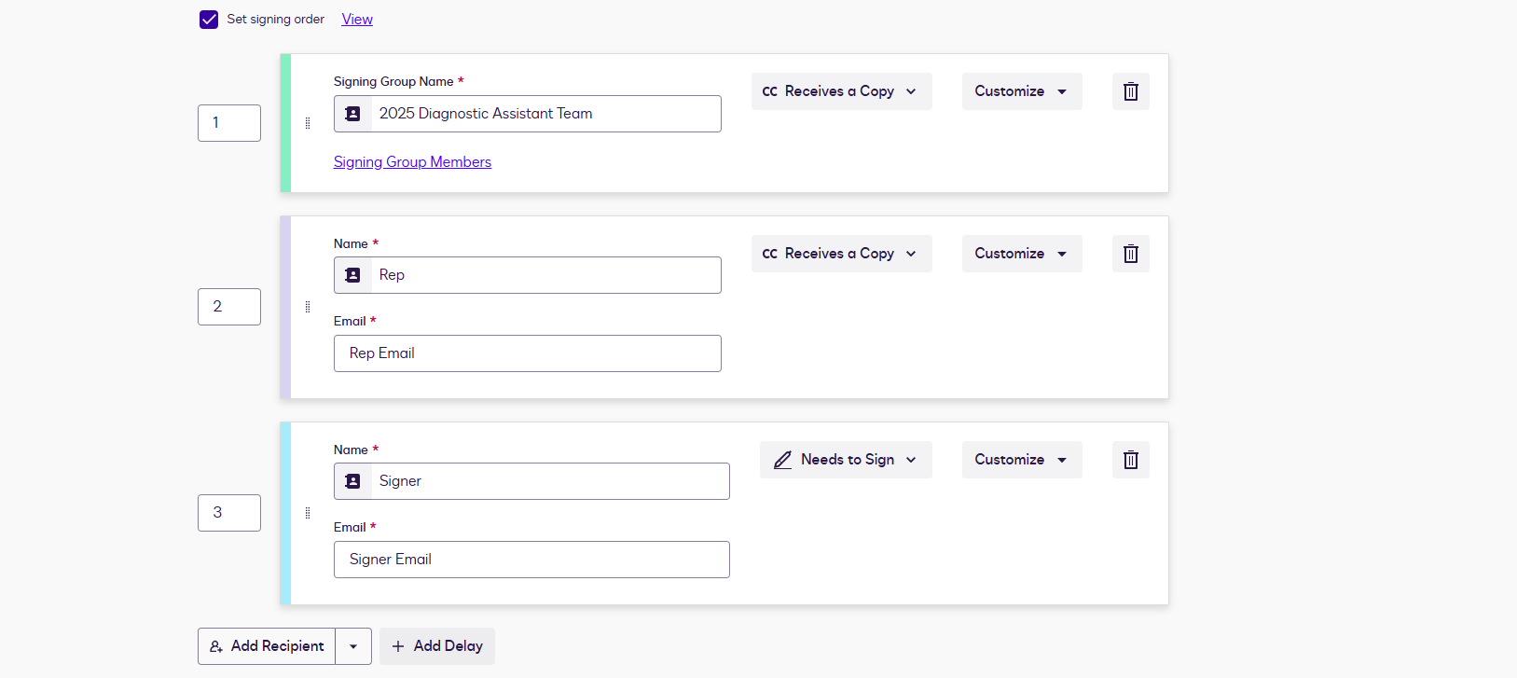
  - Add Message
    - Subject will autopopulate upon PDF being loaded. For Message, use the following template:
      - Hello,

Please click the "Review Document" button above to be presented with the Labcorp license agreement for Diagnostic Assistant. Upon completion, we will reach out with next steps in enabling Diagnostic Assistant.

If you have any questions, feel free to reach out to us at DiagnosticAssistant@labcorp.com.

Thank you! 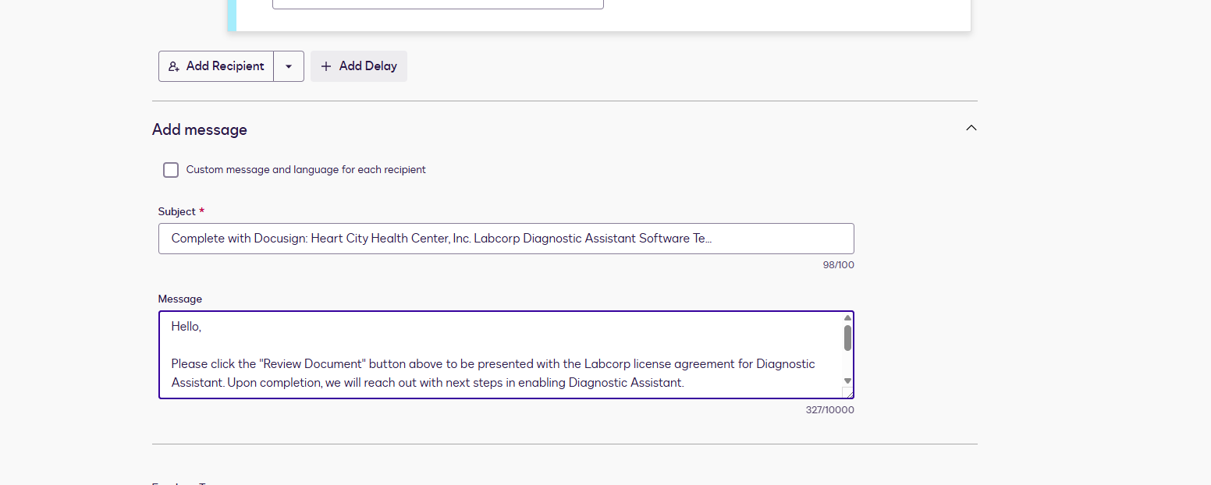
      - Once all information is inputted, hit Next button in bottom right.
  - Insert Fields
    - On next page, go to page 20 for the fields that need to be completed by Authorized Signer.
    - For Signature, select Signature standard field
    - For Phone Number, Practice Name, Athena Practice ID, and eClinicalWorks URL (as applicable) use the Text standard field 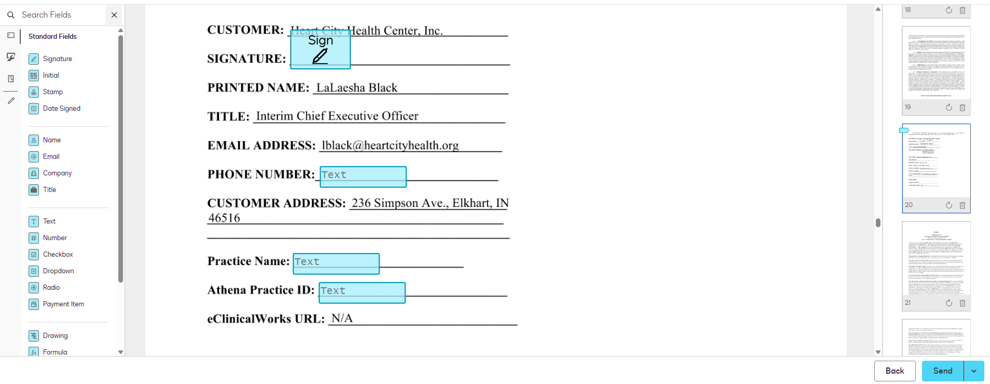
    - Hit send once complete and you are done!
- Athena Automation
  - Athena clients do not need to be inputted into the automation queue until they are configured in Control Center and the A&C is submitted.
  - Once signed and the configuration is complete, go to Athena Clients.xlsx and input the respective fields from the info provided by client/rep.
  - Make sure to put No for CKD Pilot. This cannot be blank. Kick Off Info Sent will autopopulate once the kickoff goes out so that can be left blank as well.
- Pipeline
  - Don’t forget to enter the customer into the pipeline once sent!

